Task 1: Using ChatGPT as Your Learning Assistant
Task 1: Using ChatGPT as Your Learning Assistant

Question:
Hey hi, I'm new to Devops and started learning devops with step by step concepts. In that I have a doubt about the protocol in networking concepts. I need a clear explanation for that with few examples to understand as a beginner.

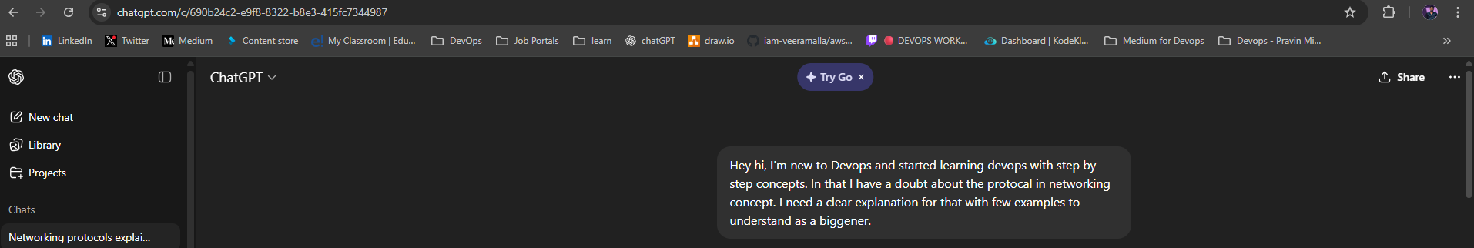

Response:

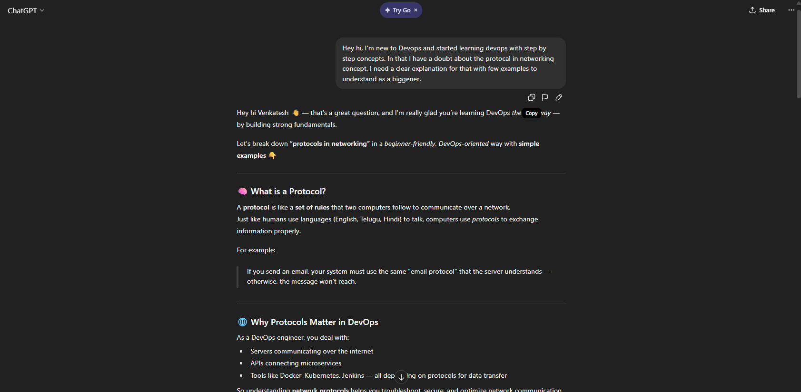

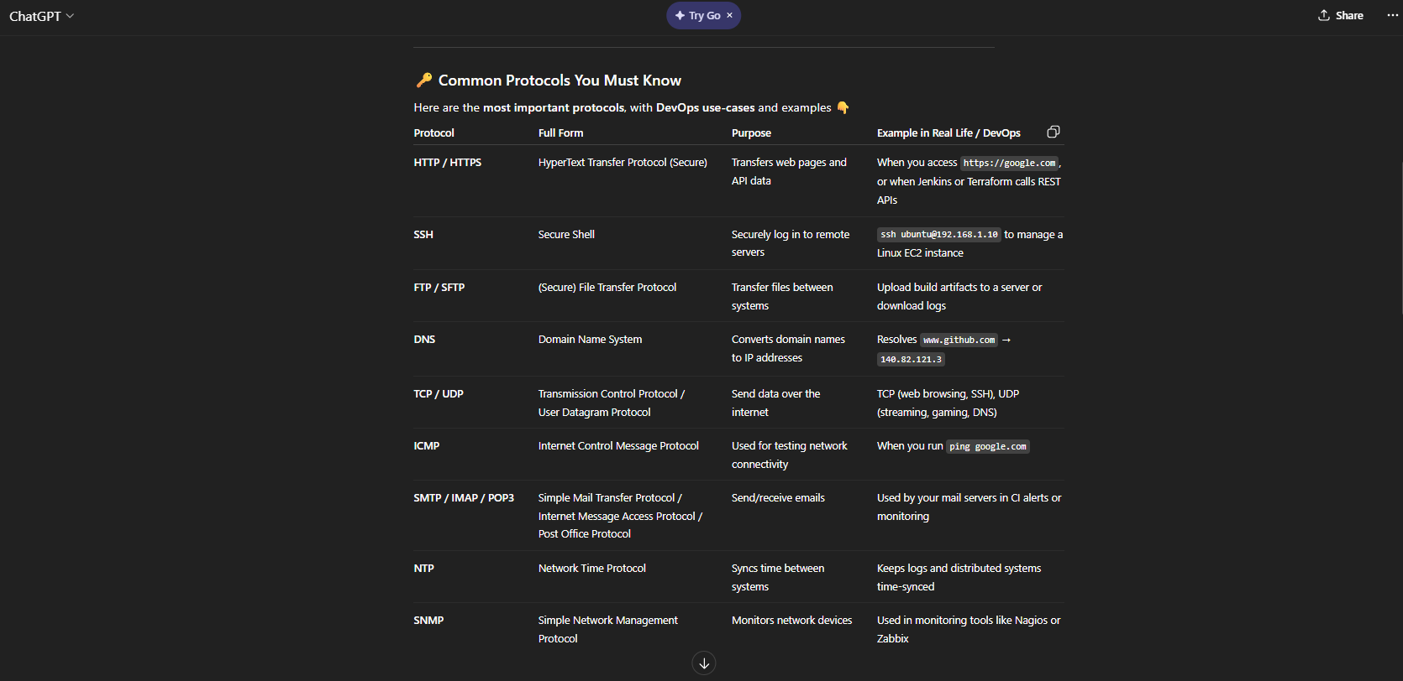

Examples:
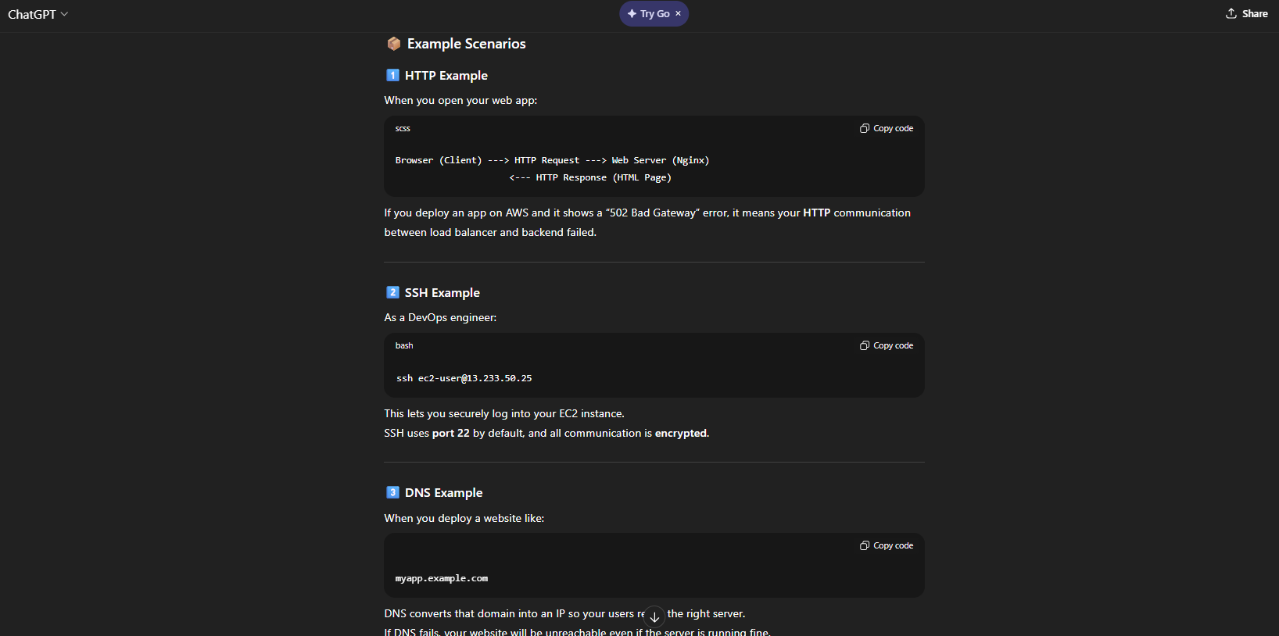

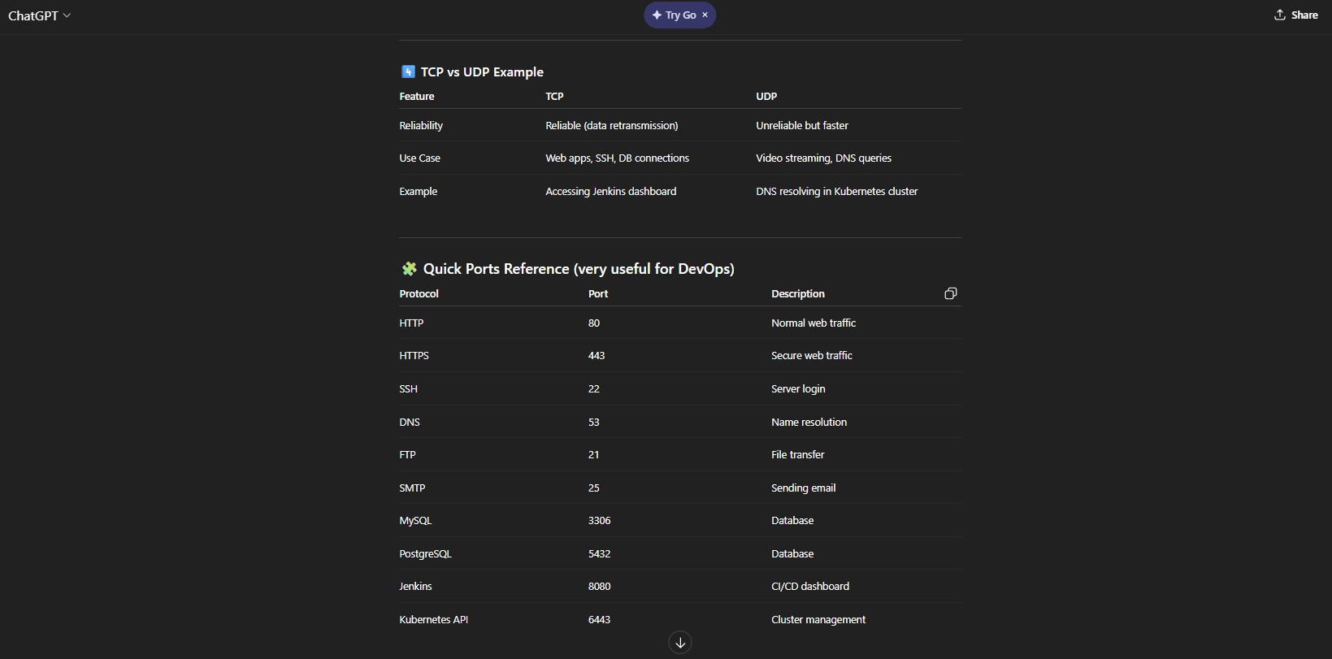

Interaction:

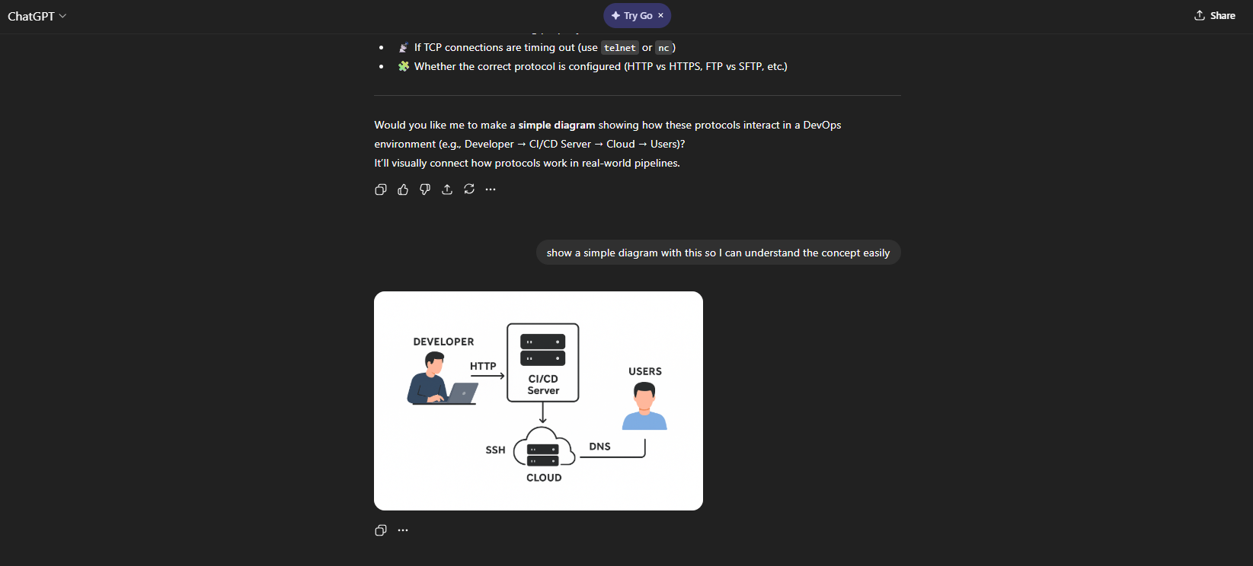

Task 2 : Internet and Networking
Task 2 : Internet and Networking

Scenario:
Your website, EpicReads, is hosted in Finland and needs to be accessible to users globally.
When the website is registered with a domain name system (DNS) such as https://www.epicreads.com, it is linked to an IP address — for example, 185.231.240.1. This IP address acts as the destination that users around the world connect to.
Example:
If a user in India wants to access your website, their computer (with an IP address like 49.205.113.20) sends a request to https://www.epicreads.com.
The DNS translates this domain into the corresponding IP address (185.231.240.1) and directs the request toward the web server located in Finland.
This request is divided into small data packets and transmitted through multiple routes across routers, ISPs, and undersea cables using a technique called packet switching. When the packets reach the EpicReads server in Finland, they are reassembled in the correct order.
The server then sends a response back to the user’s computer in the same way — through data packets that get reassembled to display the webpage.
The TCP (Transmission Control Protocol) ensures that these packets are delivered reliably and in sequence, while the IP (Internet Protocol) handles the addressing and routing of the packets between the user and the server.
Once the connection is established, the web browser and web server communicate using HTTP or HTTPS protocols.
The key difference is that HTTPS (Hypertext Transfer Protocol Secure) encrypts the data using SSL/TLS, ensuring that user information such as login credentials and payment details are kept safe.
Since EpicReads is a global online bookstore, it’s essential to use HTTPS to maintain security and trust for all international users.
Hence, using this combination of DNS, IP addressing, packet switching, TCP/IP communication, and HTTPS security, users anywhere in the world can seamlessly access the EpicReads website hosted in Finland.

Task 3: Application Architecture & Stack
Task 3: Application Architecture & Stack

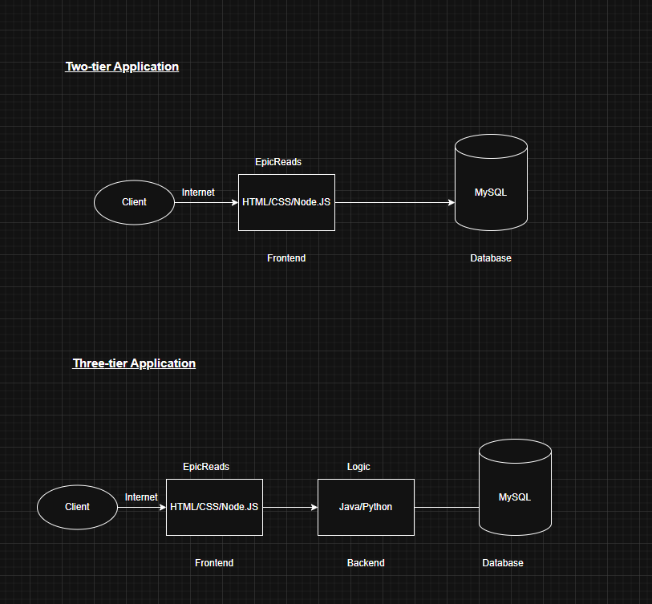

Task 4: Domain Name & DNS (Basic Concepts)
Task 4: Domain Name & DNS (Basic Concepts)

- What is DNS(Domain Name System)?

DNS (Domain Name System) is like the phonebook of the Internet. It translates human-readable domain names (like www.epicreads.com) into machine-readable IP addresses (like 185.231.240.1), allowing computers to locate and communicate with each other over the network.
Let’s take an example of how DNS works when a user visits www.epicreads.com:
- Local DNS Cache:
The browser first checks its local cache to see if it already knows the IP address for www.epicreads.com.
  - If found, it uses the cached IP directly.
  - If not, it moves to the next step.
- Recursive DNS Resolver (ISP Level):
The request goes to the Recursive Resolver, usually managed by your Internet Service Provider (ISP). This resolver tries to find the IP address on your behalf.
- Root DNS Server:
If the resolver doesn’t have the IP, it contacts a Root DNS Server.
The root server doesn’t know the exact IP address, but it directs the resolver to the appropriate Top-Level Domain (TLD) server — for example, the .com server.
- TLD (Top-Level Domain) Server:
The .com TLD server knows which Authoritative DNS server manages the domain epicreads.com.
It sends back the location of that authoritative server.
- Authoritative DNS Server:
The Authoritative DNS Server holds the actual DNS records for epicreads.com.
It returns the IP address — for example, 185.231.240.1 — for www.epicreads.com.
- Response to User:
The Recursive Resolver passes the IP address back to the user’s browser, which then connects to the EpicReads web server in Finland.
The IP is also cached locally for faster access next time.

There are different types of DNS records and each DNS record has a specific purpose.
- A Record: It maps Domain name to an IPv4 address, which is used for most common websites.
Example: epicreads.com → 185.231.240.1

- AAAA Record: It maps Domain name to an IPv6 address, which is used for IPv6 networks.
Example: epicreads.com → 2001:db9::1

- CNAME Record: It maps one Domain name to Another Domain, which is used for Subdomains or Aliases
Example: www → epicreads.com

- MX Record: Its purpose is to configure Domain to mail server, which is used for Email routing.
Example: mail.epicreads.com

2. Which DNS record type should be used to connect the domain to the given IP and why?

We should use an A Record to connect a domain name to a given IPv4 address because it maps the domain directly to the server’s IP address. This allows web browsers and users worldwide to locate and access the website seamlessly through the Internet.

Task 5: Visual Studio Code Setup (Hands-on)
Task 5: Visual Studio Code Setup (Hands-on)

User: Venkatesh Gangavarapu

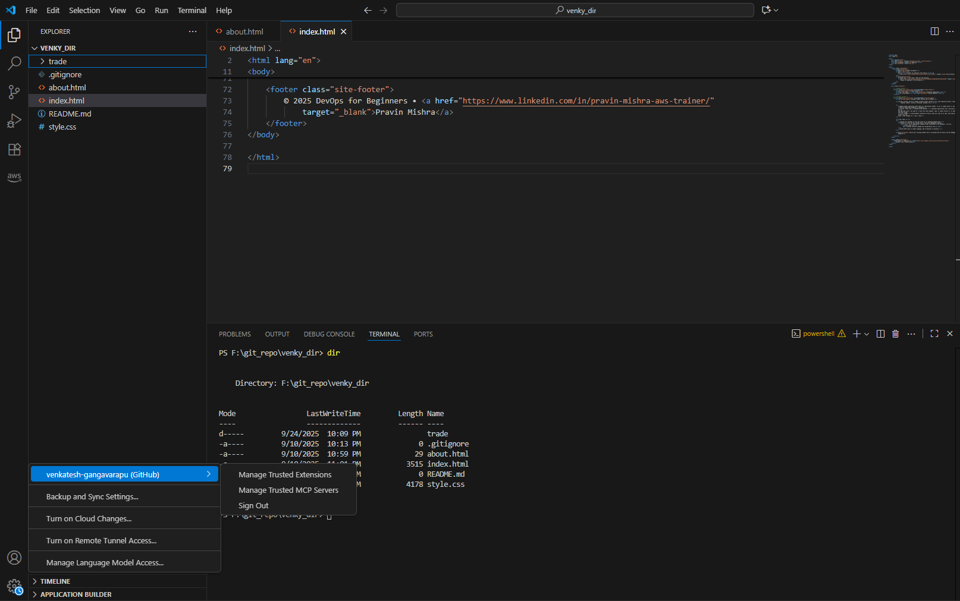

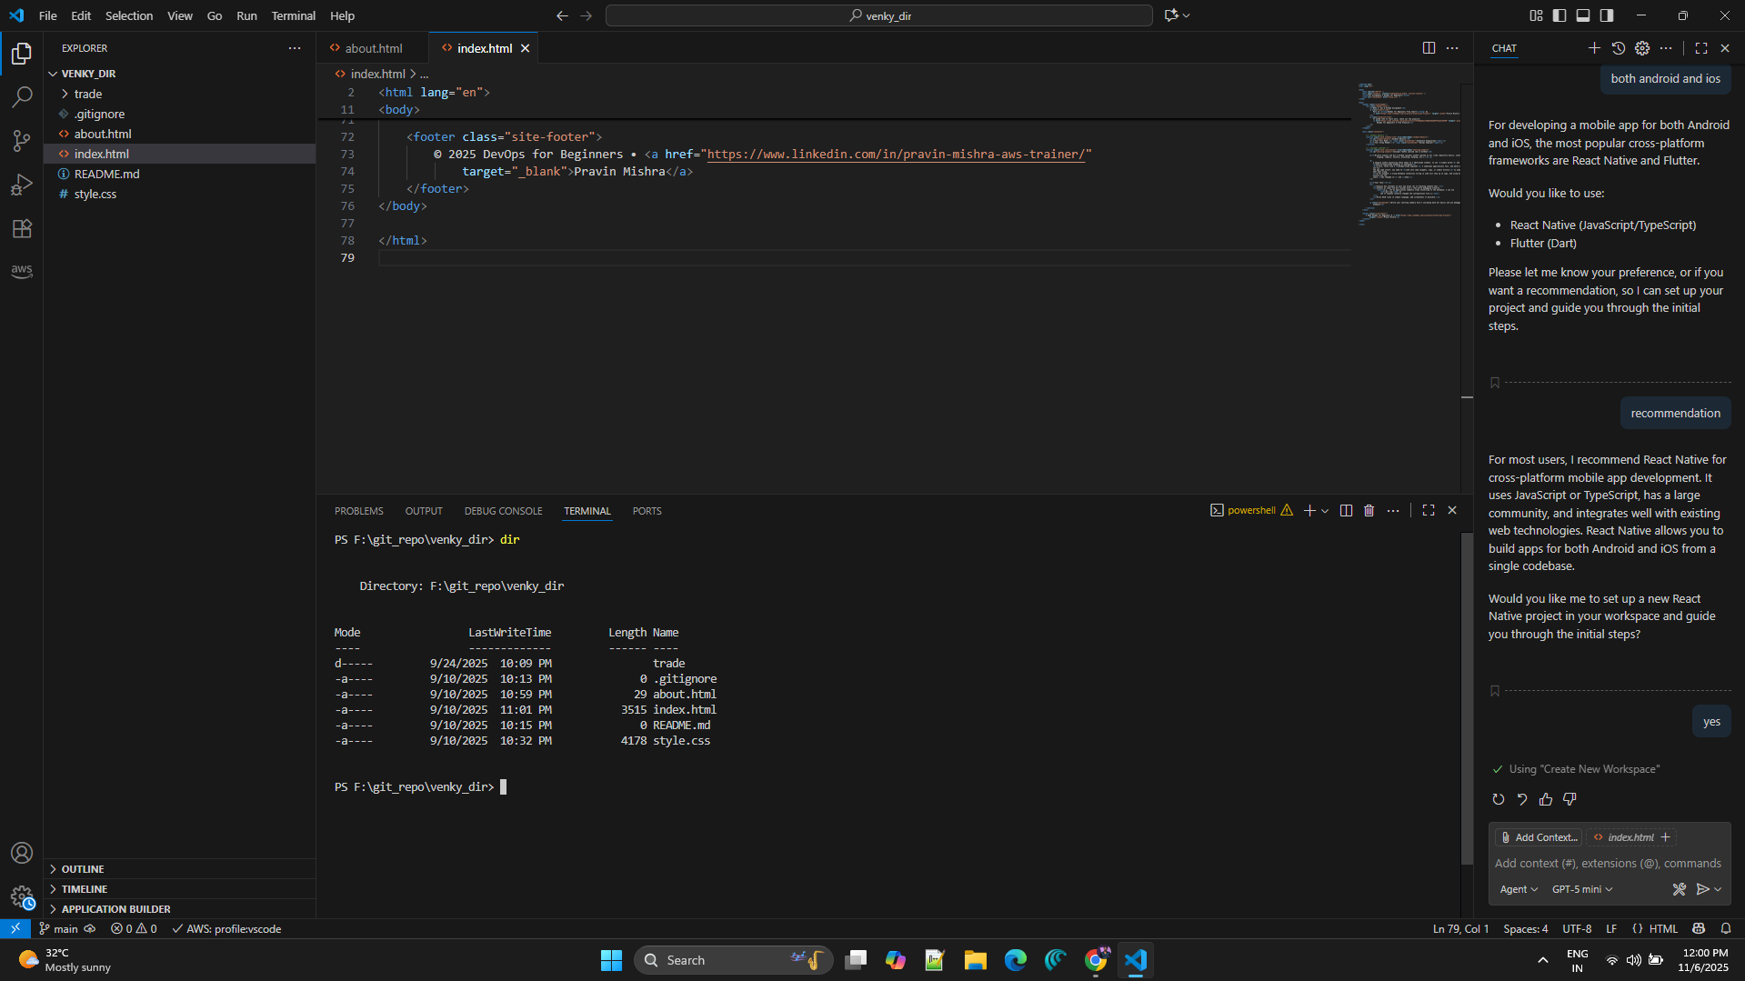

Task 6: Publish Your Assignment as a LinkedIn Post
Task 6: Publish Your Assignment as a LinkedIn Post

Posted Successfully on LinkedIn by the Username: Venkatesh Gangavarapu

https://www.linkedin.com/posts/venkatesh-gangavarapu_devops-micro-internship-tasks-activity-7392090482228477952-f-Al?utm_source=share&utm_medium=member_desktop&rcm=ACoAACYgXvcBA0eONh4y0e4ClVMUJnr0kVtz02s

